NAfME-C  Missouri Newsletter  Fall 2016 |  |  |  | 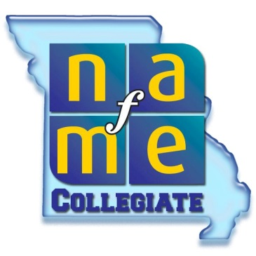
Novels for Educators  Good-bye Mr.Chips by James Hilton  Up the Down Staircase by Bel Kaufman  PYM by Mat Johnson  Dancing in a Distant Place by Isla Dewar  The Kids from Nowhere by George Guthridge  The Music Teacher by Barbara Hall  Informative Books for Educators  The Perfect Wrong Note by William Westney  Musicophilia: Tales of Music and the Brain by Oliver Sacks  Satchmo: My Life in New Orleans by Louis Armstrong  Treat it Gentle by Sidney Bechet  Beethoven’s Hair by Russell Martin |  | “Education isn’t just about feeding the brain. Art and music feed that heart and soul.” – Julie Garwood  Featured School: Truman State University  The Truman State University NAfME-C chapter has planned several exciting events for this year. Double reed professor Elaine AuBuchon will be presenting on the Feierabend method during the October meeting and the chapter is hosting a half-day workshop and reading session on October 29th for NAfME-C members and area music teachers. This session will include presentations from Truman faculty including repertoire and approaches for handling performers of mixed ability in the strings classroom, repertoire and approaches for incomplete instrumentation for band, and choral repertoire and approaches for the changing male voice. These sessions will include open reading with music supplied by JW Pepper and a focus on middle-school repertoire. In addition to the NAfME-C chapter events, the music department has been busy as well. On October 8th and 9th SAI hosted the annual New Horizons Music Festival, featuring works by guest composer Kala Pierson as well as guest ensemble Exit 128 from Mizzou. The festival also premiered Truman’s contemporary music ensemble, Uncommon Practice. In addition to these events, Wind Symphony I will be performing Reflections on the Mississipi with Professor Bo Atlas and will be performing at MMEA this January.
“The man that hath no music in himself, nor is not moved with concord of sweet sounds, is fit for treasons, stratagems and spoils.”  –William Shakespeare |  | Professional Development  Professional development can seem difficult for pre-service educators, but it doesn’t have to be. Contact your local schools to see what their teachers need or want help with. One great way to get involved with students during the fall is to host mock auditions for District Band or offer masterclasses for students who are auditioning in November. This practice can be used in the spring as well in preparation for Solo and Ensemble Festival. Professional development also isn’t limited to classroom experiences. Reading on topics of interest that may not be covered in classes, such as exceptional learners or topics on minority students, can be a rewarding way to enhance your knowledge of education and may pique an interest you may have never experienced otherwise.  “Music has a power of forming the character, and should therefore be introduced into the education of the young.” - Aristotle
MMEA Pre-Registration  Haven’t registered for MMEA 2017 yet? Pre-registration is not only easy but less expensive than on-site registration. You must be a registered member of NAfME in order to register for MMEA. Follow the links below to register:  Register with NAfME: www.nafme.org  Register for MMEA: www.monafmec.weebly.com |  |  | 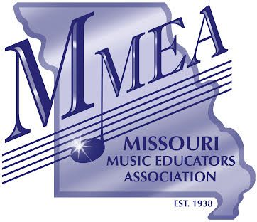
Like our Facebook Page | Questions or Comments?  Contact Your Officers:  President  Dylan Fornshell- fornshelldylan@gmail.com  VP Membership  Cristin Selle- cgs8364@truman.edu  VP Programming  Emily Walling- eaw69220@ucmo.edu  Secretary  Chandler Cooper- cooper007@live.missouristate.edu

